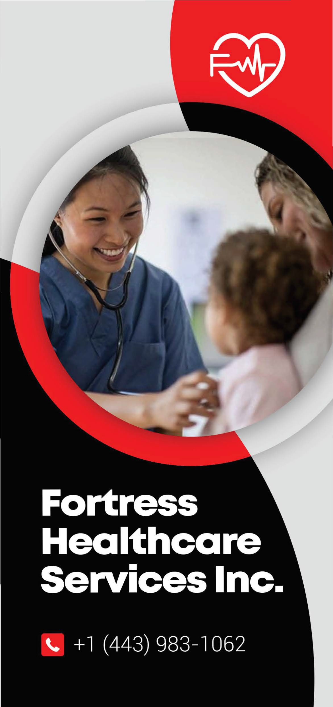

**Mission**

To be the best staff and nursing care provider; ensuring our clients/ individuals are provided with professional and experienced staff and nursing care to help achieve their goals.



**Why Choose Us**

We are a reliable, trusted and swift service provider

Highly skilled, trained and screened Healthcare team.

Quick recovery process.

Quality and excellent services for the wellbeing of clients and individuals.

Safe, conducive and friendly atmosphere for our client's well-being.

Leaving a lasting satisfacto ry impression.

Speedy and excellent service prov isions to ensure we are always

your only option.



**Geographic Area Served**

We are licensed to provide services in Maryland USA

**About Us**

Our agency provides Residential Healthcare services (RSA) to homes and Healthcare Staffing Services to hospitals, clinics, long term care facilities, nursing homes, assisted living facilities, group homes, etc. in Maryland.

1. Choose Fortress Healthcare for
   * dependable service and a skilled team.
2. Experience swift recovery and
   * outstanding care.



**Motto:**

Your health and wellness our priority!!!!